23rd Sunday in Ordinary Time, Year A
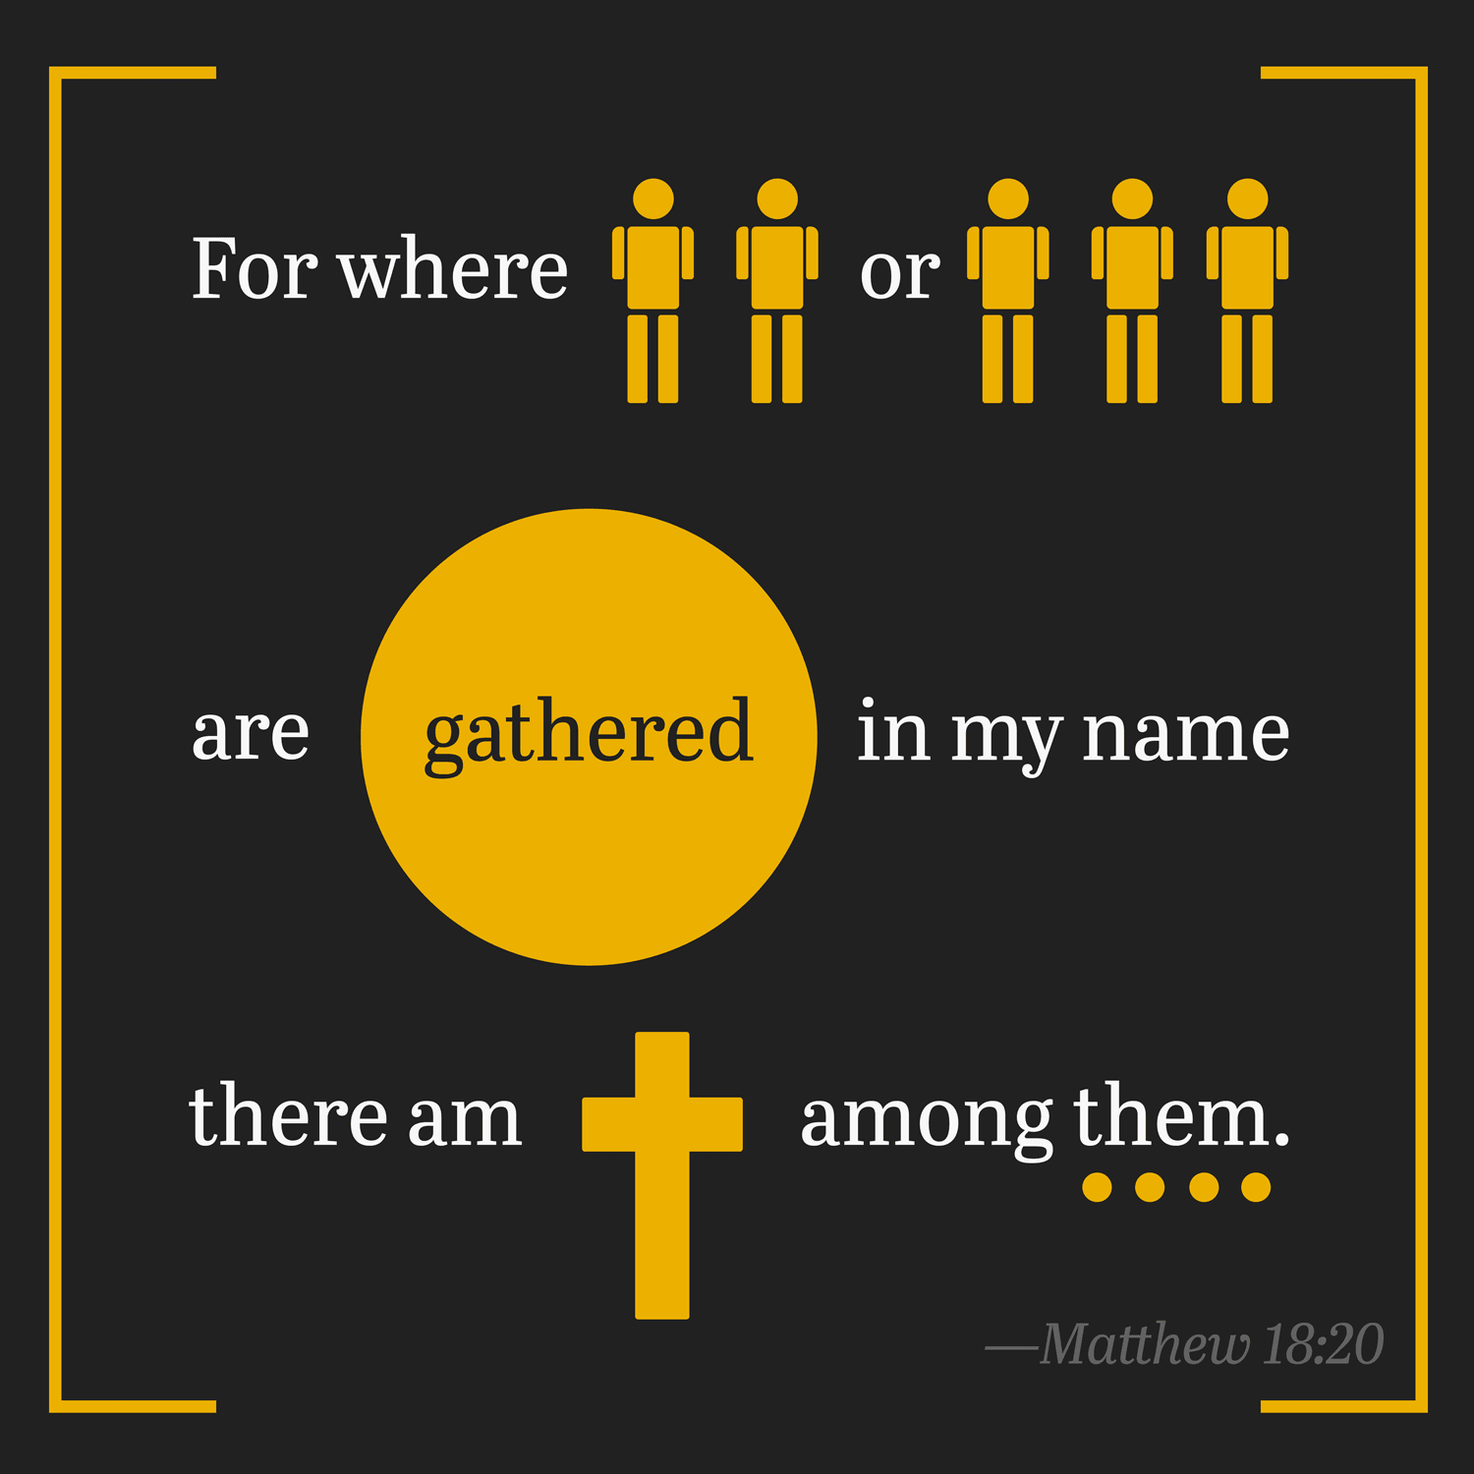

1st Reading: Ezekiel 33:7-9
As a preacher, Ezekiel has the responsibility to warn sinners to repent
The word of the Lord was addressed to me as follows,
“You, mortal, I have made a sentinel for the house of Israel; whenever you hear a word from my mouth, you shall give them warning from me. If I say to the wicked, “O wicked ones, you shall surely die,” and you do not speak to warn the wicked to turn from their ways, the wicked shall die in their iniquity, but their blood I will require at your hand. But if you warn the wicked to turn from their ways, and they do not turn from their ways, the wicked shall die in their iniquity, but you will have saved your life.”
Responsorial: Psalm 94:1-2, 6-9
Response: If today you hear his voice! Harden not your hearts.
Come, ring out our joy to the Lord;
hail the rock who saves us.
Let us come before him, giving thanks,
with songs let us hail the Lord. Resp:
Come in; let us bow and bend low;
let us kneel before the God who made us
for he is our God and we
the people who belong to his pasture,
the flock that is led by his hand. Resp:
O that today you would listen to his voice!
‘Harden not your hearts as at Meribah,
as on that day at Massah in the desert
when your fathers put me to the test;
when they tried me, though they saw my work.’ Resp:

2nd Reading: Romans 13:8-10
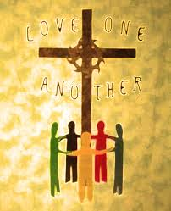
St Paul condenses all the commandments into “love one another”

Owe no one anything, except to love one another; for the one who loves another has fulfilled the law. The commandments, “You shall not commit adultery; You shall not murder; You shall not steal; You shall not covet;” and any other commandment, are summed up in this word, “Love your neighbour as yourself.” Love does no wrong to a neighbour; therefore, love is the fulfilling of the law.
Gospel Acclamation:
Alleluia, Alleluia!
God was in Christ, to reconcile the world to himself;
and the Good News of reconciliation he has entrusted to us.

Alleluia!

Gospel: Matthew 18:15-20
Fraternal correction within the Christian family
Jesus said to his disciples, “If another member of the church sins against you, go and point out the fault when the two of you are alone. If the member listens to you, you have regained that one. But if you are not listened to, take one or two others along with you, so that every word may be confirmed by the evidence of two or three witnesses. If the member refuses to listen to them, tell it to the church; and if the offender refuses to listen even to the church, let such a one be to you as a Gentile and a tax collector.
“Truly I tell you, whatever you bind on earth will be bound in heaven, and whatever you loose on earth will be loosed in heaven. Again, truly I tell you, if two of you agree on earth about anything you ask, it will be done for you by my Father in heaven. For where two or three are gathered in my name, I am there among them.”

REFLECTIONS:
In recent years, disclosures about paedophile priests have shocked and dismayed many Catholics. Old priests with long experience of dealing with sinners and their sins, with all their sordid-ness, were known to have broken down and wept. That a fellow-priest betrayed his sacred trust with the most innocent of all victims, a child, was beyond their comprehension. What angered people most of all was that his superiors knew about his child abuse aberration for years. How many victims might have been spared had those superiors removed him from ministry.
This issue is clearly linked to today’s Gospel where the Lord Jesus said to his disciples: “If your brother does something wrong, go and have it out with him alone, between your two selves. If he listens to you, you have won back your brother.” Then there is a further process if he does not listen, and finally, “if he refuses to listen to the community, treat him like a pagan or a tax collector.” One wonders whether Christ had anything as heinous as child-abuse by a disciple in mind, when he gave them those practical instructions.
Ironically some who preach against permissiveness can be guilty of its grossest forms. Permissiveness, with its tragic consequences, is symptomatic of our times. We want the privileges of power without its burdens by trying to pass the buck and shifting the responsibility for something to somebody else. We shy away from problems, cast a blind eye, shirk the responsibility to speak out. And when the scandal leaks out we want to claim we didn’t know. But such ignorance is rejected in Ezekiel where the Lord says: “I have appointed you as sentry to the House of Israel.” And he went on to state plainly: “If you do not warn the wicked man to renounce his ways, then I will hold you responsible.”
Therefore, in the spirit of service, the main task is not be to be popular but to be of help. And we help most by accepting our responsibility.
Further in this view, today’s readings confront us with two aspects of the question. Firstly the need for a sense of individual responsibility in the way of conversion. Ezekiel certainly made it clear that the individual is addressed by the Word of God calling for repentance. There is no way out of this personal responsibility.
When Ezekiel preached he was a prisoner in enemy territory and he could warn that it was not external force, but the enemy within, that is the real threat to life: that enemy is sin, the abandonment of God. It is the prophetic role of the Church to continue this preaching (even if its voice is treated like something coming from foreign soil.) The gospel of Christ is that life and peace come from faith in God and the doing of his will. This gospel calls us to repentance but is no mere denunciation of sin.
Moreover, the Church is called to be supportive of each person who seeks reconciliation. This is especially important in a world where so many people feel threatened by the alienating force of impersonal state structures. The Church is not called to be mega-corporation. The Church is called to to help and serve, to transform and renew, to unify and love, to protect the Christian values and fulfil the will of God.
Individuals who are perplexed by their own failures or oppressed by the weaknesses of others, need a community that does not drive them further into isolation but one which calls them through forgiveness and love into the life of fellowship. Living in this fellowship does mean that we owe debts to one another, and as Paul reminds us today the only obligation that ultimately counts is the debt of love we owe one another.
This reconciled community will be an effective sign to the world not because it creates a superficial harmony, but because it faces the reality of sin in itself. It finds forgiveness as the solution to this threat. Renewal of the ministry of reconciliation in the Church increasingly takes the form of communal services of penance, linked to the celebration of the sacrament. This is an effective way of bringing home to people that all sin effects the community and reconciliation must include the community.

